Notes by Dave Askin – 17/7/2021

NOURISH – Pruning your fruit trees
Contents
NOURISH – Pruning your fruit trees 1
A word about the internet 1
Starting well- keys to success 1
Safety? 1
Starting with the right trees? 2
General pruning notes 2
Why prune: 2
When to prune: 3
How to prune: 3
Apples – Vase or Centre Leader? 3
Peaches/Nectarines and apricot 4
Grapes – Starting easy! 5
Plums 5
Black and Red Currants, Raspberries and Gooseberries 5
Raspberries 5
Red currants 6
Really big, old trees, way out of control- what do we do with these? 6
SUMMARY- key points to have in mind for main fruit trees 6

Hygiene –There’s a lot written on the internet about disinfectant and bleach etc. Seems bleach is a no-no. It is corrosive to your tools.
Disinfectant also – some say is no good. So, for today we will use fungicide itself in a dip. Pls use between trees.
I’ve been known to use a few seconds on a gas fire to burn off disease from my secateurs.
Much has been written about pruning. Lots of it’s good – even very good, but it takes an age to get through all the writing in textbooks or on the web. So here are notes to get you started and the real learning is focused around us going out and doing pruning together.

A word about the internet
Chase down the web sites that have .edu or .ac in their title. These are professional sites (often government research sites), providing advice based on experience and experiment. The discussion forums are all very well but remember people may make statements that have little or no evidence to support their advice.

Starting well- keys to success
- Start with the right trees, then
- Plant them well and stake so they don’t move in the wind destroying developing roots.
- If you have bought a nursery tree – eg ex Waimea, it will need severe pruning once planted. Why? To form prune – create the tree you want and to honour the need for balance. Many of its roots were cut when it was lifted out of ground and popped in a planting bag. It has lost a lot of ability to feed water and nutrients to the tops. So pruning now is an absolute must.
- Don’t put lots of horse or other fresh manure in the planting hole. It will rot down and leave air holes that will dry out and your tree is likely to die. (That fresh manure is great as mulch above ground).
- Control weeds/grass in a circle of at least 2 m diameter. Mulch well with straw or old carpet, cardboard weighed down... Just stop the grass growth (somehow) as it competes for moisture and nutrients. Mowing isn’t what I have in mind here! But you may want mown lawn right up to the base of trees – no worries – just remember to feed the area under drip-line of tree branches with water and fertiliser/manure to help grass and trees.

Safety?
- Secateurs don’t mind eating your finger. Take care!
- Ladders tip over on the uneven ground of an orchard. That’s why orchard ladders have three legs.
- Pruning saws are great for those large branches on old trees that have ‘got away’ over years. They eat fingers also!

Starting with the right trees?
The photos below show two trees, one on the left a great specimen, and the one on the (far) right, at least one season too old and well passed its use by date for us as purchasers in a nursery. Arrows explained below.
At the nursery… A story of two very different trees…
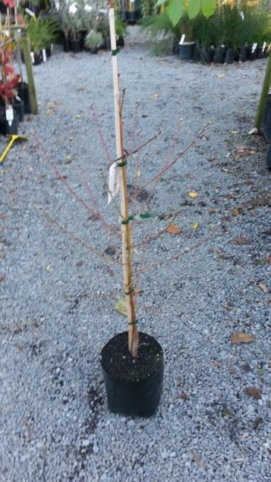 | 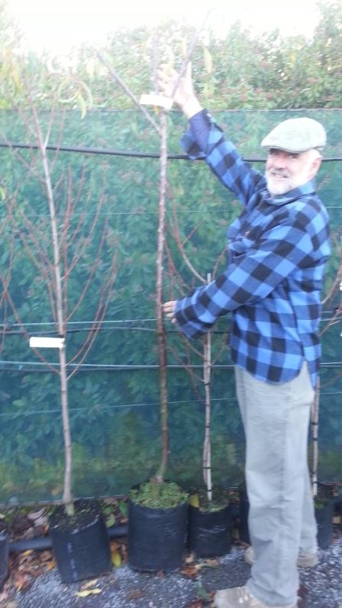
Young grafted peach tree, ready for planting, and needs pruning for form/shape into future.  Really nice young tree. But next to it in the nursery | This is a tree to avoid like the plague. It should have been sold at least a year ago, but has been held over for a whole growing season in a nursery. Now the main growing points are above head height. No branches to carry fruit until well above my head. Imagine the challenge of making something good of this?! Avoid. (It will be VERY root bound also).If you can’t avoid buying this kind of tree, prune hard at planting.
The arrows in photos indicate the general zone where you look for 3-4 branches that are healthy and ready to become the main form of a vase into the future. Cut above those to start that vase shape.
That is a tough cut to make. Probably the hardest cut in all pruning tasks! So much lovely wood is lost, but it is worth it later.
The healthy branches that will grow strongly beneath your pruning cut can be grafted to provide 3 different trees in the one tree. Grafting is for another training day!
You have to tip back the branches after that main centre is cut out. Aim to look for buds pointed in the right direction.

General pruning notes
Modified from - http://www.tuigarden.co.nz/print/howtoguide/fruit-tree-pruning-guide
Before you tackle pruning your fruit trees, ensure you know why you are pruning and that you have the right tools for the job.
Not all fruiting plants require an annual prune, and some new dwarf cultivars of apples, peaches, apricots and nectarines have been bred to eliminate the need for annual pruning and maintenance.

Why prune:
- To reduce the size of the tree, to allow for easier picking and harvest.
- To increase fruit size/quality.
- Shape trees so that they carry a heavy load of fruit, without breaking branches. (some support may still be needed).
- Try a branch with your hand – to assess load bearing ability. If weak, prune back.
- To allow more sunlight and air movement into the plant: a small bird should be able to fly through the centre of the tree. Improved air movement prevents pest and disease problems developing and more light encourages even ripening.
- To remove dead and diseased branches and stems.
- Remove branches that are too close to each other – causing rubbing.

When to prune:
- Apples and pears - prune every autumn after harvest (or winter- but increased disease issues) to ensure a good crop of fruit the following season. Note that sometimes due to seasonal fluctuations, pears become biennial fruiters, fruiting better every second season. Mostly those strong upright branches get pruned well back, side ways growth is often the fruiting spurs – go easy here.
- Feijoas, olives, figs, Chilean guavas and citrus - prune after harvest finishes in autumn or winter. In cold areas, don’t prune citrus until after the frosts have passed. It is not necessary to prune every year.
- Nectarines, peaches, almonds and plums - prune in summer or early autumn. (I prefer straight after fruit harvest, but you have to have time then!)
- Winter pruning may lead to spread of silver leaf, which stone fruits are prone to.
- Grapes- prune in winter, back to main vines – leave one bud and tie back any long new branches or canes to train into shape.
- Cherries and blueberries - do not require a lot of pruning, other than to shape and to remove dead or diseased wood. Both fruit on the same wood for years. Cherries still require shaping when young.

How to prune:
- Prune on a dry day, to limit the spread of fungal spores and diseases.
- Ladder, a belt with a pouch for secateurs – oh so handy! Short ladders are dangerous – tie on firmly a vertical guide stick as shown on the day when we gather. Car tubing is wonderful stuff.
- For vase shaped trees, aim to keep the height uniform across the whole of the vase. If not, vigour will tend towards the highest branch.
- Use sharp secateurs to make clean cuts on an angle, above a bud or branch. Cut close to the bud and aim to cut to a bud that is pointing in a direction you want growth.
- Some people do a good job of removing lots of the fruiting spurs on apples. Don’t, unless too many apples are small. Remember water…! Is a big part of fruit size. Removing fruiting spurs will mean you do less thinning!
- Remove all clippings and prunings and dispose of dead and diseased material.
- Clean, dry and oil tools after use.
- Spray deciduous fruit trees in winter with a copper based spray to eradicate over wintering diseases. Spores can over-winter and are spread by air and moisture, as well as tools.
- After cutting – esp. large branches a pruning paste that has some fungicide in it, is a good idea. How effective is it? Not sure!

Apples – Vase or Centre Leader?
It’s a case of your choice – whether to prune your apples / pears to centre leader or vase. We’ll discuss both.
A key for all pruning is to keep fruiting within reach or at least within easy reach on a ladder.
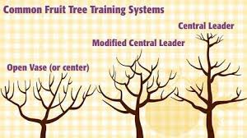
Open or vase pruning requires a cut low in the tree when it is young, to establish three or so main branches that form the structure.
The central leader is pruned and then trained to develop a series of almost horizontal tiers that carry the fruit on strong branches. For central leader – each year in first few years one stem is allowed to grow strongly – the centre leader, and other branches are pulled down towards horizontal.
Forget the modified image in middle, above…, that is just to confuse us. Or maybe to prove that the rules can be bent and broken and the fruit will still taste awesome!
This site does a good job of describing centre leader apple and pear development.
http://extension.psu.edu/plants/gardening/fphg/pome/pruning/pruning-and-training-to-a-central-leader/first-growing-season It is based ex USA, so inches reign and seasons are back to front. Principles remain.
Eg-
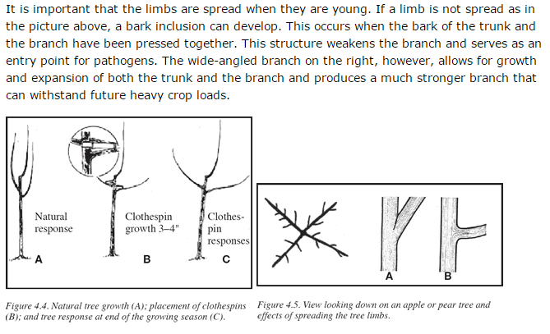
Apples/pears fruit on last years wood/spurs – so those little spurs on apples and pears – that’s a prime site for flower and fruit development. You may need to reduce those on older trees, so that you don’t get too many fruit. If an apple carries a very heavy load of fruit it may skip the next year. Called biennial bearing.
It’s fine to allow those spurs to remain down low – makes real easy picking.

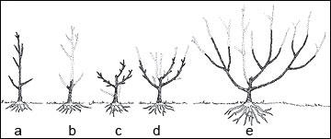
Vase pruning explained in pictures. Buy the tree, unpruned from nursery. The left hand one in my photos above. Prune when planted. I wouldn’t be so harsh with the side pruning of the branches in b above.

Peaches/Nectarines and apricot
- Mostly you are looking to produce the shape of tree in diagrams above (vase).
- These can suffer from a lot of dieback. Little and not so little branches just die. Remove dead wood.
- Start by setting height of the vase allowing the tree to get a bit larger each year. Keep the height the same across all of your branches.
- Now cut out a few largish branches in the vase – if necessary to open the tree up… they can get awfully crowded.
- Now trim many of the small branches back by about 2/3 – keep in mind strength to carry a load of fruit. Job done. (Removing 2/3 of a fruiting branch helps reduce fruit load and increases fruit size).

Grapes – Starting easy!
http://www.grapegrowingguide.com/grape-pruning.html but they seem to only have grapes growing on one wire. I’m greedy! I like more fruit, and a more fence like structure, or the grape is to provide shade/shelter on a pergola. Aim to allow main vines to grow and be supported along the key structures on your fence or pergola. Each winter prune off all side shoots. Back to one bud only – named renewal spur below.
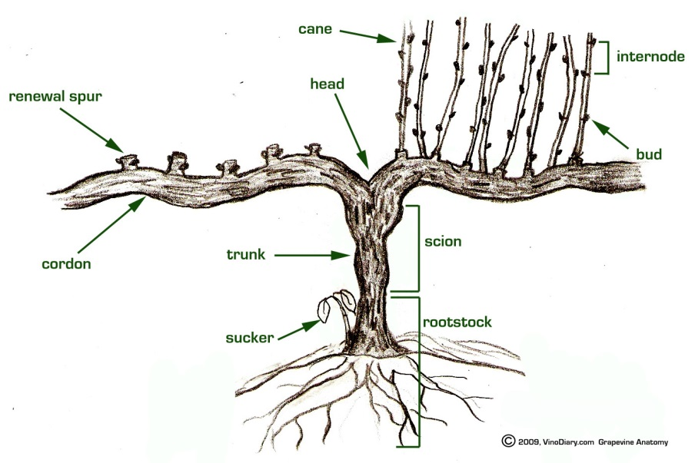 | After pruning on left.  Unpruned on Right.  That’s the principle, but you can allow more than two main vines (called cordons in image) to grow on your grape. The picture depends on what the grape is doing for you.  I like to have shelter, wind protection.  Those requirements modify what I allow to grow.

Plums
- Normally pruned in late summer, after harvest.
- Normally trained as per vase pruning.
- They fruit on last year’s growth.
- Manage similar pruning techniques to peach/nectarine.
- Autumn pruning is good, after fruit is harvested.

Black and Red Currants, Raspberries and Gooseberries
From - https://www.rhs.org.uk/advice/grow-your-own/fruit/blackcurrants
Prune blackcurrants when dormant – from late autumn to late winter. Fruit forms on young wood, so when pruning aim to remove older wood, leaving the young shoots.
Up to and including the fourth year after planting, remove weak, wispy shoots, retaining a basic structure of six to 10 healthy shoots. After year four, cut out about one-third of the older wood at the base, using a pair of loppers or a pruning saw. This will encourage and make room for younger, healthy wood. Also remove weak shoots and low ones leaning towards the ground.
For years Virginia managed our black currants. At harvest we cut the whole of the stem which was carrying a heap of fruit and carried it off for processing the fruit. By doing that we made space for new growth which had been happening while the older branch was producing the fruit. Remember they will need water and fertilizer to remain productive and healthy.
We treat raspberries much the same. Old stems get cut out, allowing young new stems room for growth. Gloves help with raspberries.
Gooseberries require minimal pruning, lots of water and fertilizer – aim to get them up off the ground.

Raspberries
From - http://www.greenhaus.co.nz/tipsraspberrypruning.html
It's time to sharpen up the pruners and head to the raspberry patch for a bit of midwinter gardening. With a bit of good care at this time of the year you hardly need to touch your patch again until it is time to harvest.
Proper pruning of raspberries is essential to obtain top yields. Pruning produces higher yields by increasing berry size. It also helps control diseases. Pruning procedures are based on the growth and fruiting characteristics of the plants. The growth and fruiting characteristics of raspberries are unique. The plant's roots and crown are perennial, while the stems or canes are biennial. This means a raspberry plant may grow and produce fruit for many years.
However, individual canes live only 2 years and then die. The first year the canes of most raspberries only grow up and produce a lot of leaves. The second year these canes will flower and fruit and then die. Raspberries need plenty of sun to produce a good crop and if the dead canes are left, they will deprive your plant of a lot of light. At this time of year it is quite easy to see the dead canes, they are usually a darker colour and much more branched then the 1 year old shoots. You start your pruning by removing all the old canes as close to the ground as possible. If you are doing this every year your plant might still be fairly thick after you have removed the old canes, in this case you might want to take some of the thinner new canes out and only leave the thicker ones. It is best not to let your raspberry patch get much wider than half a meter as it would be difficult to harvest. Commercial growers actually only plant raspberries in one row and when pruning only leave 8-14 canes per meter.
Also if your patch gets too wide it will restrict the air movement through it and thus increase the chances of fungal decease. To remove any canes that have grown past your area, just put your spade down in between the plant and the cane to be removed and pull it out. You might want to give these canes to neighbours and friends to start their own raspberry patch.
I find it quite useful to put posts in every corner and tie wires in between the posts so that the canes don't start hanging too far out into your path when they get heavy with fruit. While you are doing the pruning it is also a good time to clean up any weeds that might be growing in between.
Add some compost as fertiliser and cover with what ever mulch that you might have available, raspberries love humus and organic fertiliser.

Red currants
A bit different – well very different to black currants.
https://www.rhs.org.uk/advice/grow-your-own/fruit/redcurrants (note this is a reputable site – royal hort society in UK – they have to know a heap about this stuff). Here’s what they say-
Redcurrants bear their fruit on old wood. Prune bushes by removing diseased or very old branches in winter, then prune new growth back to two buds in early summer to keep plants compact. Leaders should be pruned to outward facing buds unless the branches are bending, in which case they then should be cut to upward facing buds.
In early spring, prune established cordons. Cut the new growth on the main vertical stem by a quarter of the previous year’s growth, or by half if growth is weak. Cut to a bud on the opposite side to the previous year’s cut to keep the growth straight. Once the cordon is at the desired height, cut to one bud of new growth each year in early summer. Prune the shoots from the main stem to one bud to build up a fruiting spur system.

Really big, old trees, way out of control- what do we do with these?
These are a whole different challenge. They end up – if plums- like an umbrella – all dark and shady inside/under the tree and they fruit just on outside 500 mm of depth of tree. Fruit size will diminish, flavour will be just fine. Oh and you’ll need a big ladder!
They need a 3-5 year program of rejuvenation.
You can’t bring them to rights in just one season of severe pruning.
You will need to cut – maybe with a small chainsaw some branches out… but do this step by step. Cover the cuts with acrylic paint OR an anti-fungal pruning paste.
Letting light into the heart or base of most any tree will tend to stimulate new branches that can form the base of a re-invigorated tree. It takes time.
You may stimulate really vigorous growth. Those new shoots may be grafted to various cultivars to give better quality fruit.
You may just plant a new tree – esp if the old one is structurally weak/old/diseased, but most old trees can throw out new, vigorous shoots for grafting.

SUMMARY- key points to have in mind for main fruit trees
- Start by looking at tree – assess what you want, what needs to be done. Walk around. Look carefully.
- Hold loppers or saw in hand. Big jobs come first. Remove major broken or dead or crossing branches that rub on each other.
- If mowing down low, or movement around tree is a problem – remove some key bothersome branches.
- Think congestion of too many branches in the tree. You may need to remove some large branches to let light in.
- Think height – this applies for both centre leader and for vase shaped trees. Aim to take out the big wood first as you bring the height down.
- Aim to have height uniform across the vase shape.
- Think fruit load. If too many buds (nectarine, peach, apricot) or fruit spurs (pear/apple) – thin them.
- Apples/pears grow many long vertical shoots each season that are cut back very hard each year in a mature tree.
- Peaches, nectarines have challenges with die back, so remove the dead shoots, then think about fruit load/branch strength – and reduce length of most last years wood by 2/3. They fruit on last year’s growth.
- Think about grafting in some pollinator wood or another cultivar. That’s a whole other story.

